Resource sheet – Fire-stick farming


Benefits of fire-stick farming
Australia has been separated from other continents for 45 million years. Native plants evolved in dry, nutrient-poor soils and were sometimes burnt by natural fires caused by lightning. The plants adapted to thrive in these conditions. As a result, many of Australia’s native plants and animals are unique.

When Indigenous Australians arrived in Australia about 50 000 years ago, they used fire to increase the amount of food available. This is called ‘fire-stick farming’. Many plants and animals adapted to these small, regular fires. The plants and animals that didn’t adapt became extinct.
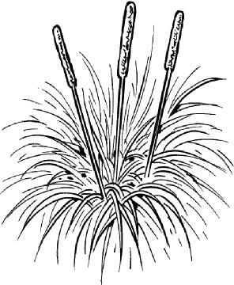
Fire-stick farming increased the amount of food because:
- Small animals killed by the fire could be collected and eaten.
- Nutrients from burnt plants went back into the soil,
- helping food plants such as bush potatoes to grow.
- New plant growth after the fire attracted animals. Their footprints in the bare soil made them easier to hunt.
Fire-stick farming also helped in other ways.
- It ‘cleaned up’ the landscape by removing small trees and bushes, making it easier and safer for Indigenous Australians to travel.
- It helped in the survival of animals and plants that had adapted. For example, Banksia plants now need fire so their seeds can germinate.
- It increased biodiversity. Natural fires along with regular fire-stick farming produced more different types of habitats for animals and plants to live in.
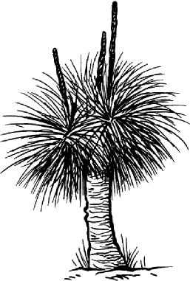
When European settlers arrived in Australia they didn’t use fire-stick farming. Some of the plants and animals that had adapted to small, regular fires became threatened or extinct. Without regular fires, forests build up a lot of leaf litter, which fuels fewer, bigger fires that destroy lives and habitats.

